**Scalability:**

1.cost of physical resource :

NO idea

2. controlling the performance loss : time complexity of searching algorithm is O(n)

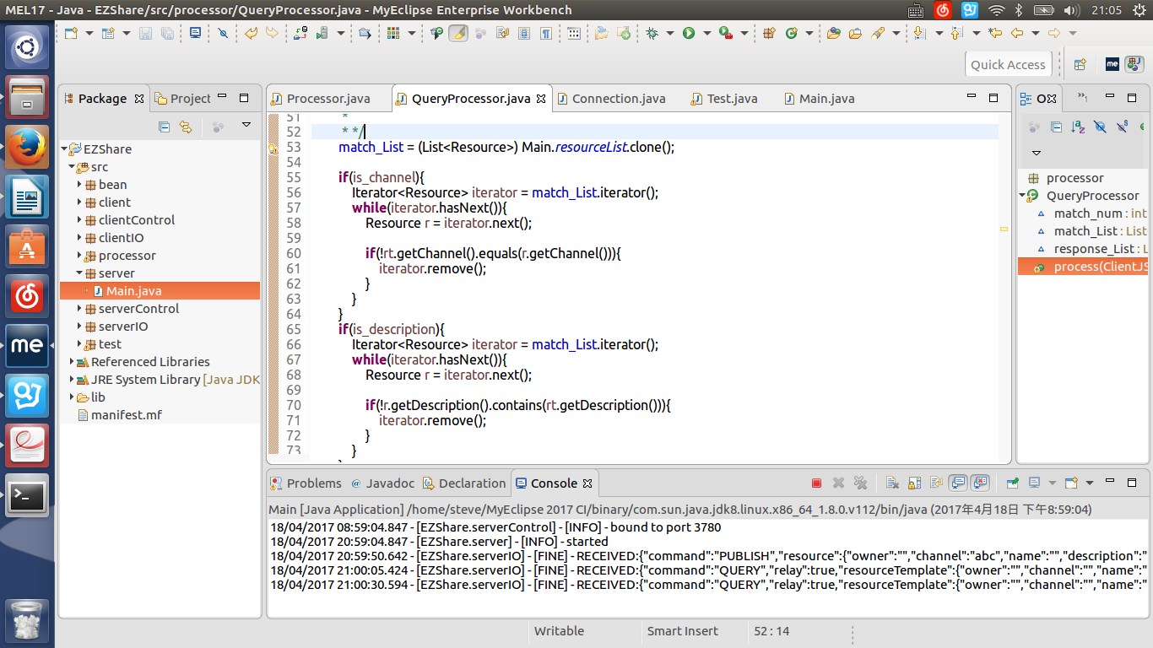

use only one loop to resolve query.

3. Resource should not be run out: Server.Main.java

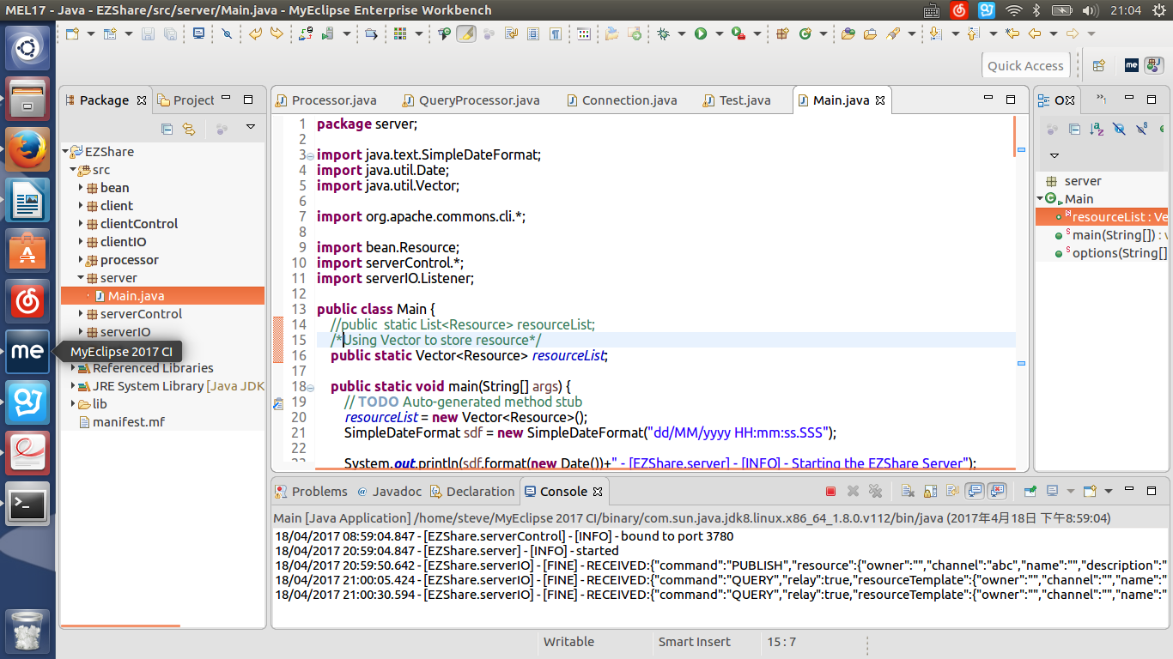using Vector to store resource,(line16)

the maximum capability of Vector = Integer.MAX_VALUE-8 = 0x7fffffff-8 (refer to java.util.Vector.class)

size of Vector from 10→0x7fffffff-8

4. Avoiding bottlenecks NO idea

**Concurrency:**

using Vector (synchronized List) to implement Resource list.